

**Peak Centre Project Requirements**

In this project requirements document, user stories will be illustrated in four modules with two different user types.

User Types:

* Administrators
* Athletes

Modules:

* User Account
* Test Result
* Training Plan
* Workout Summary

**1. User Account**

**For administrators**

1. As an administrator, I can use my email and password to login the website.
2. As an administrator, I can create a new administrator account. The administrator account information includes

|  |  |  |  |  |  |
| --- | --- | --- | --- | --- | --- |
| Email | Initial password | First name | Last name | Date of birth | Sex |

1. As an administrator, I can create a new athlete account. The athlete account information includes

|  |  |  |  |  |  |
| --- | --- | --- | --- | --- | --- |
| Email | Initial password | First name | Last name | Date of birth | Sex |

1. As an administrator, I can modify an administrator’s account information.
2. As an administrator, I can modify an athlete’s account information.
3. As an administrator, I can delete an administrator’s account.
4. As an administrator, I can delete an athlete’s account.

**For athletes**

1. As an athlete, I can use my email and password to login the website.
2. As an athlete, I can modify my own account information. If I change my email, I will see an alert message that I should use my new email to login in future.

**2. Test Results**

**For administrators**

1. As an administrator, I can input athlete’s test result. First I should choose the athlete name, then input test type, I should input:

*Basic Information: (different from template to template. Dynamically?)*

*Cycling*

|  |  |  |  |  |  |
| --- | --- | --- | --- | --- | --- |
| *Date* | *Weight* | *Height* | *Age* | *Gear* | *RPM* |

*Running*

|  |  |  |  |  |
| --- | --- | --- | --- | --- |
| *Date* | *Weight* | *Height* | *Age* | *Grade* |

*Test Result: (table generated dynamically)*

*Cycling*

|  |  |  |  |  |  |  |  |  |  |
| --- | --- | --- | --- | --- | --- | --- | --- | --- | --- |
| *Stage1* | *Power*  *(watts)* | *HR*  *(bpm)* | *Lactate*  *(mMol)* | *VO2*  *(l/min)* | *VO2(bpm)*  *(ml/kg/min*  *)* | *RQ* | *Kcal/min* | *CHO*  *Kcal/min* | *CHO*  *g/min* |
| *Stage2* | *Power*  *(watts)* | *HR*  *(bpm)* | *Lactate*  *(mMol)* | *VO2*  *(l/min)* | *VO2(bpm)*  *(ml/kg/min*  *)* | *RQ* | *Kcal/min* | *CHO*  *Kcal/min* | *CHO*  *g/min* |
| *…* |  |  |  |  |  |  |  |  |  |
| *Stage N* | *Power*  *(watts)* | *HR*  *(bpm)* | *Lactate*  *(mMol)* | *VO2*  *(l/min)* | *VO2(bpm)*  *(ml/kg/min*  *)* | *RQ* | *Kcal/min* | *CHO*  *Kcal/min* | *CHO*  *g/min* |

*Running*

|  |  |  |  |  |  |  |  |  |  |
| --- | --- | --- | --- | --- | --- | --- | --- | --- | --- |
| *Stage1* | *Speed*  *(km/h)* | *HR*  *(bpm)* | *Lactate*  *(mMol)* | *VO2*  *(l/min)* | *VO2(bpm)*  *(ml/kg/min*  *)* | *RQ* | *Kcal/min* | *CHO*  *Kcal/min* | *CHO*  *g/min* |
| *Stage2* | *Speed*  *(km/h)* | *HR*  *(bpm)* | *Lactate*  *(mMol)* | *VO2*  *(l/min)* | *VO2(bpm)*  *(ml/kg/min*  *)* | *RQ* | *Kcal/min* | *CHO*  *Kcal/min* | *CHO*  *g/min* |
| *…* |  |  |  |  |  |  |  |  |  |
| *Stage N* | *Speed*  *(km/h)* | *HR*  *(bpm)* | *Lactate*  *(mMol)* | *VO2*  *(l/min)* | *VO2(bpm)*  *(ml/kg/min*  *)* | *RQ* | *Kcal/min* | *CHO*  *Kcal/min* | *CHO*  *g/min* |

*(This part is also different from template to template. Dynamically?)*

*Cycling*

|  |  |  |  |
| --- | --- | --- | --- |
| *VO2 max* | *Anaerobic Threshold* | *Aerobic Threshold* | *Power* |

*Running*

|  |  |  |  |
| --- | --- | --- | --- |
| *VO2 max* | *Anaerobic Threshold* | *Aerobic Threshold* | *Speed* |

*Training Zone: (table generated dynamically)*

*Cycling*

|  |  |  |  |  |  |  |
| --- | --- | --- | --- | --- | --- | --- |
| *Zone1* | *Heart Rate*  *Low* | *Heart Rate High* | *Power*  *Low* | *Power*  *High* | *CHO (g/min)*  *Low* | *CHO (g/min)*  *High* |
| *…* |  |  |  |  |  |  |
| *Zone N* | *Heart Rate*  *Low* | *Heart Rate High* | *Power*  *Low* | *Power*  *High* | *CHO (g/min)*  *Low* | *CHO (g/min)*  *High* |

*Running (2 tables)*

|  |  |  |  |  |  |  |
| --- | --- | --- | --- | --- | --- | --- |
| *Zone1* | *Heart Rate*  *Low* | *Heart Rate*  *High* | *Treadmill Speed(kph) Low* | *Treadmill Speed(kph) High* | *CHO (g/min)*  *Low* | *CHO (g/min)*  *High* |
| *…* |  |  |  |  |  |  |
| *Zone N* | *Heart Rate*  *Low* | *Heart Rate*  *High* | *Treadmill Speed(kph) Low* | *Treadmill Speed(kph) High* | *CHO (g/min)*  *Low* | *CHO (g/min)*  *High* |

|  |  |  |  |  |
| --- | --- | --- | --- | --- |
| *Zone1* | *Outdoor Speed kmh*  *Low* | *Outdoor Speed kmh*  *High* | *Outdoor Pace*  *Low* | *Outdoor Pace*  *High* |
| *…* |  |  |  |  |
| *Zone N* | *Outdoor Speed kmh*  *Low* | *Outdoor Speed kmh*  *High* | *Outdoor Pace*  *Low* | *Outdoor Pace*  *High* |

*Fueling and Refueling (carbohydrate burning)*

|  |  |  |  |  |  |  |
| --- | --- | --- | --- | --- | --- | --- |
| *Zone1* | *30 min* | *60 min* | *90 min* | *120 min* | *150 min* | *180 min* |
| *…* |  |  |  |  |  |  |
| *Zone N* | *30 min* | *60 min* | *90 min* | *120 min* | *150 min* | *180 min* |

|  |
| --- |
| *Training Zone Comments:* |

1. As an administrator/athlete, I can view test result. First I should choose athlete name and test type. Then I should choose which date I want to view from the list, and I can see:

*Athlete’s personal information*

*Cycling*

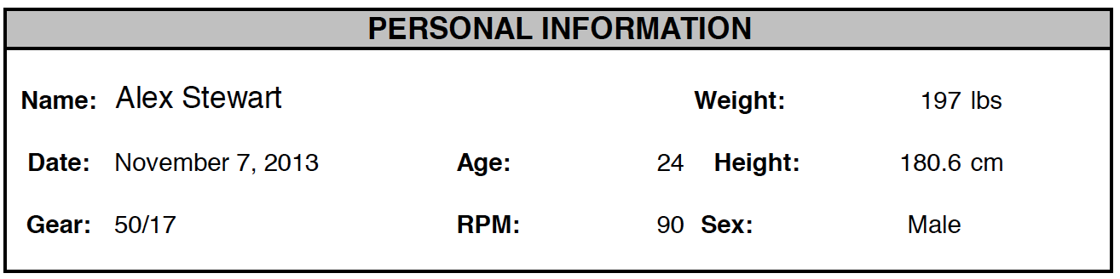

*Running*

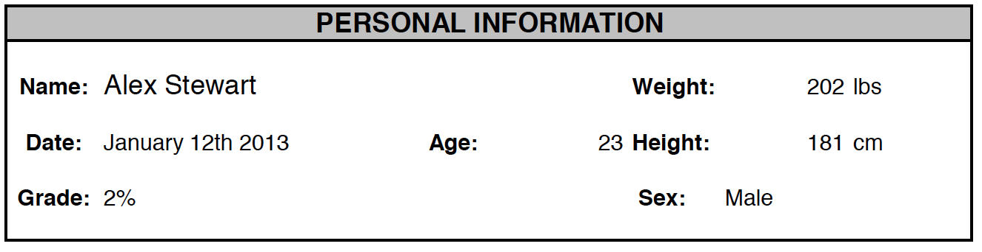

*Summary about the test*

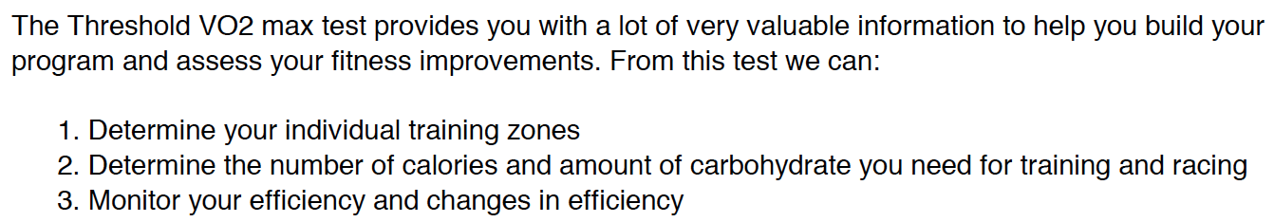

*Test result*

*Cycling*

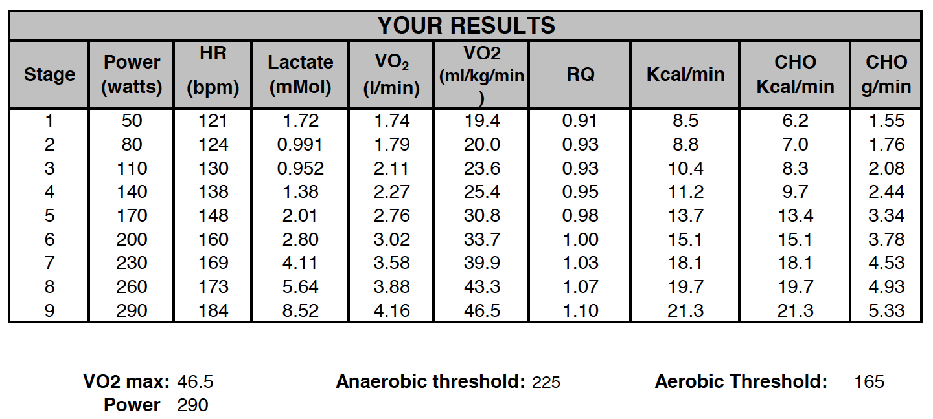

*Running*

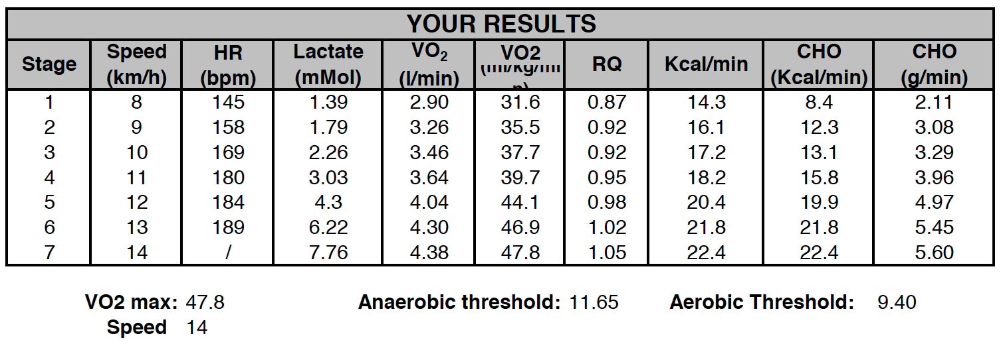

*Description about the table*

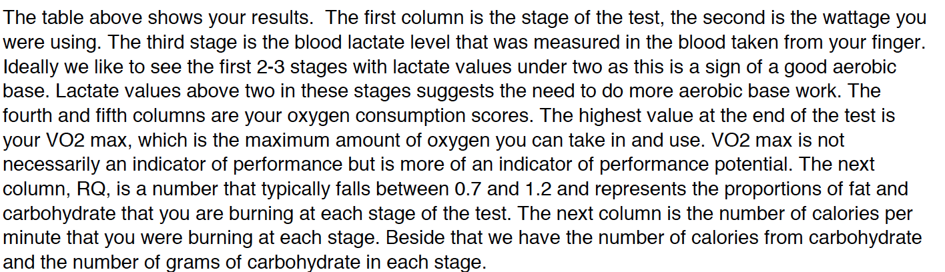

*Training Zone Description*

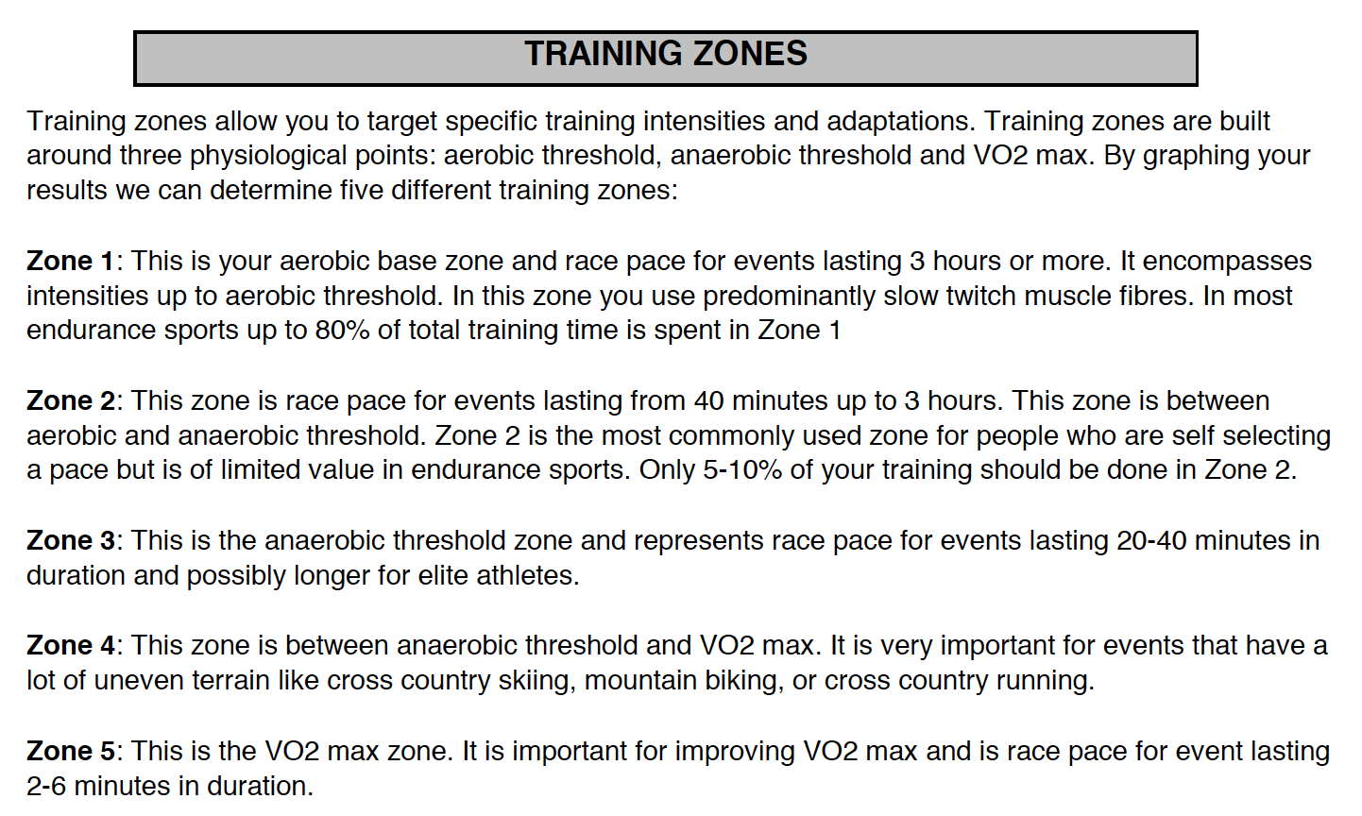

*Lactate vs. Power (Input 2 parameters and generate graph dynamically) for cycling*

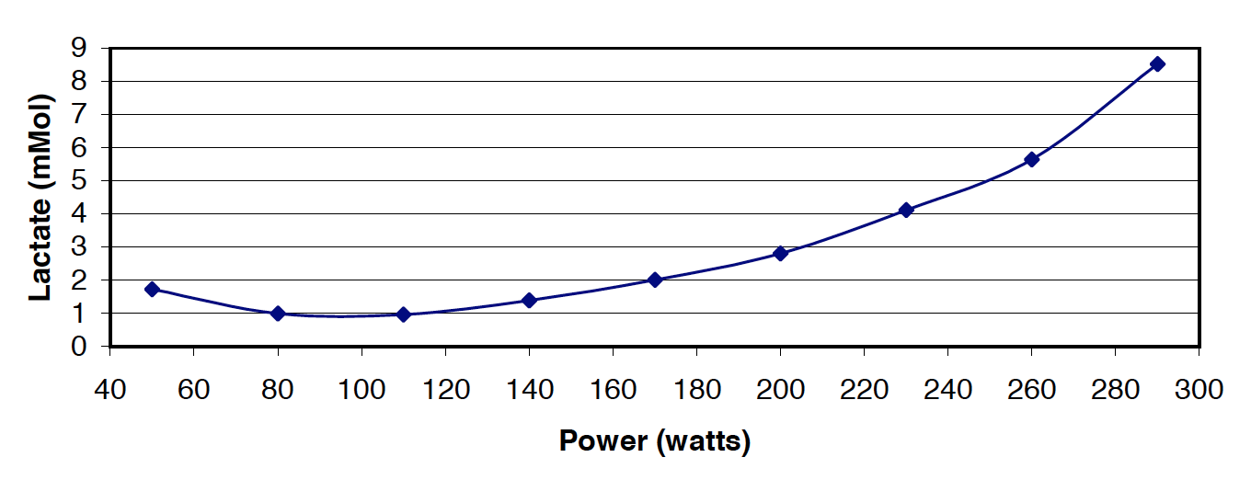

*Lactate vs. Speed for running*

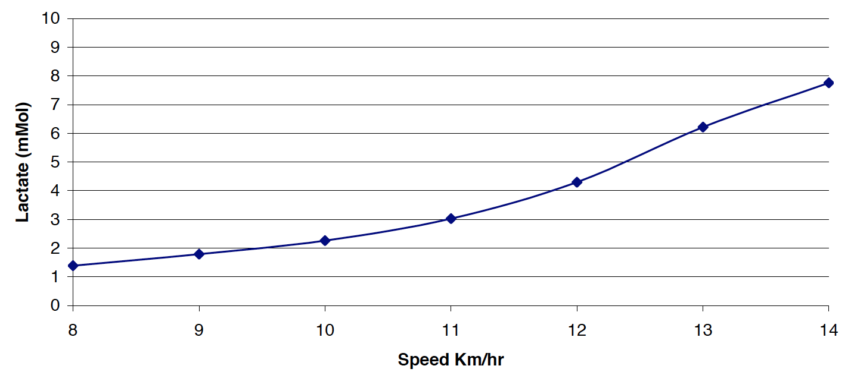

*Training zones details*

*Cycling*

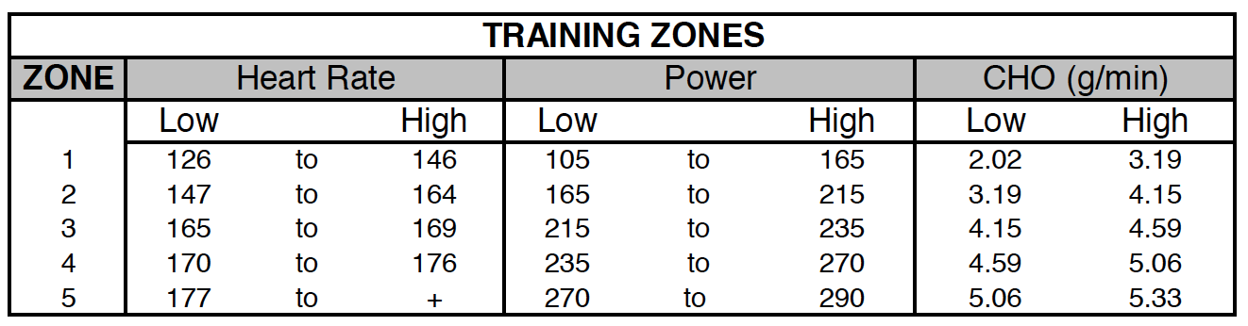

*Running*

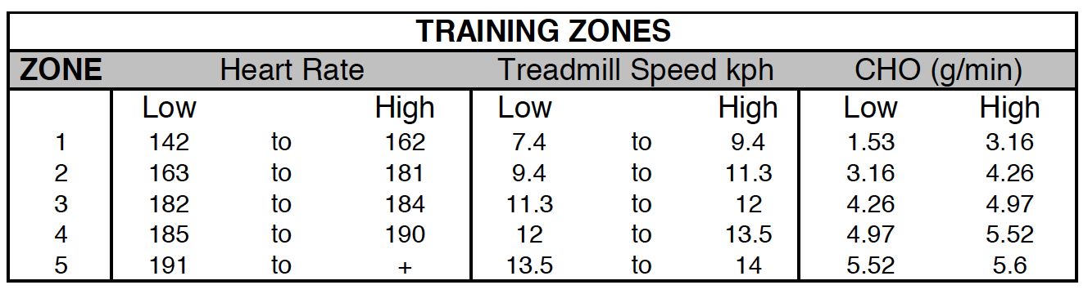

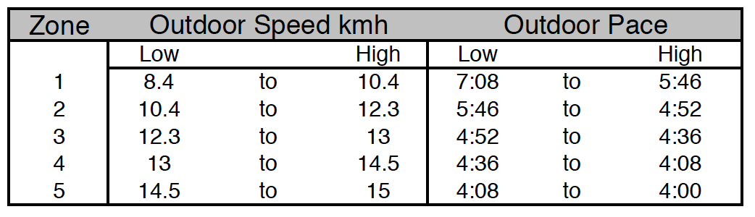

*Description of Heart Rate*

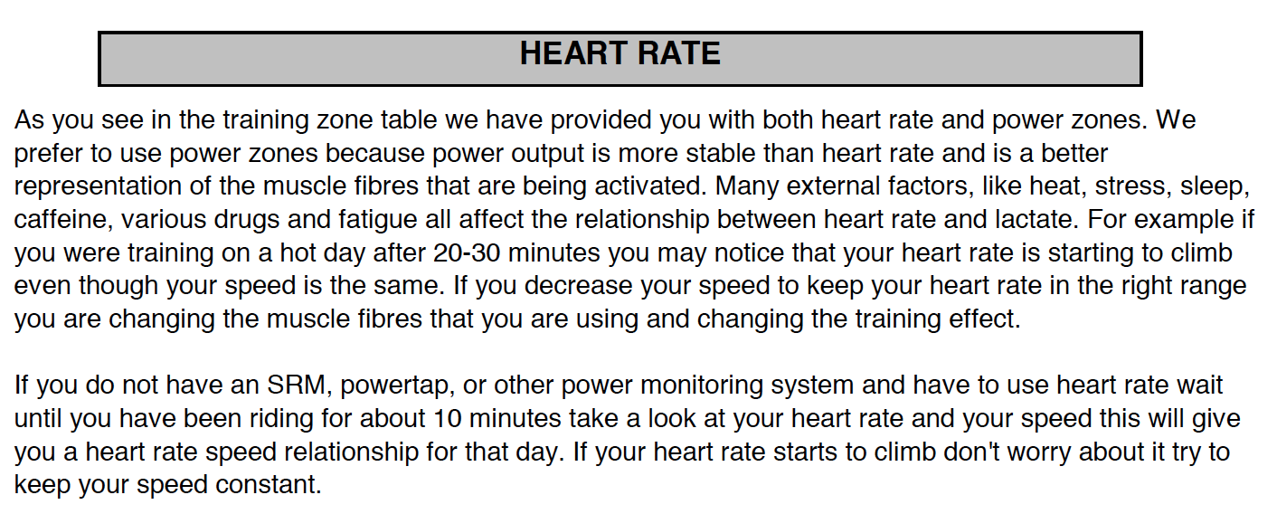

*Lactate vs. Heart rate (Input 2 parameters and generate graph dynamically)*

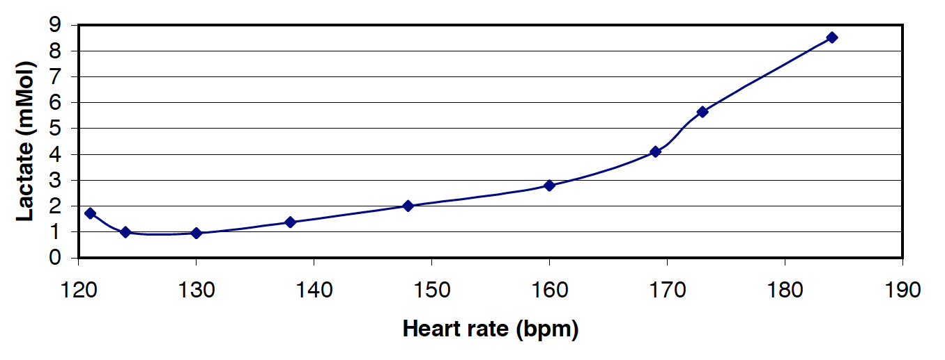

*Graph of efficiency (Generated by input) for running*

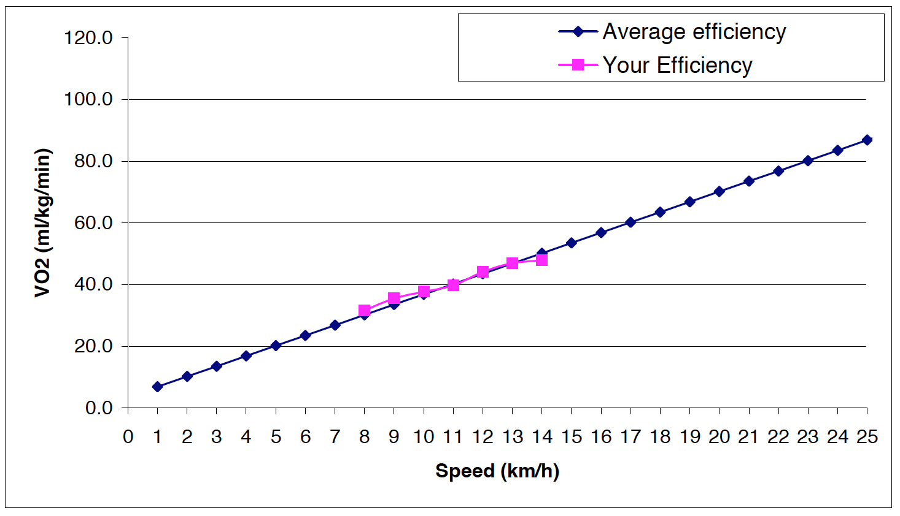

*Description about Fueling and Refueling*

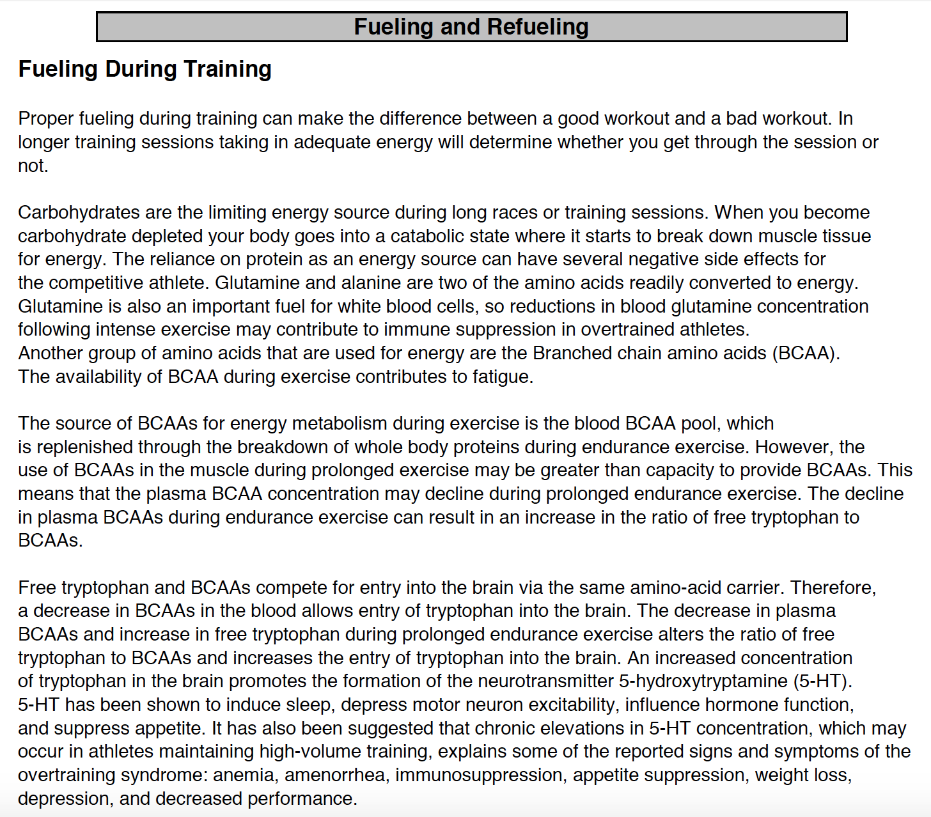

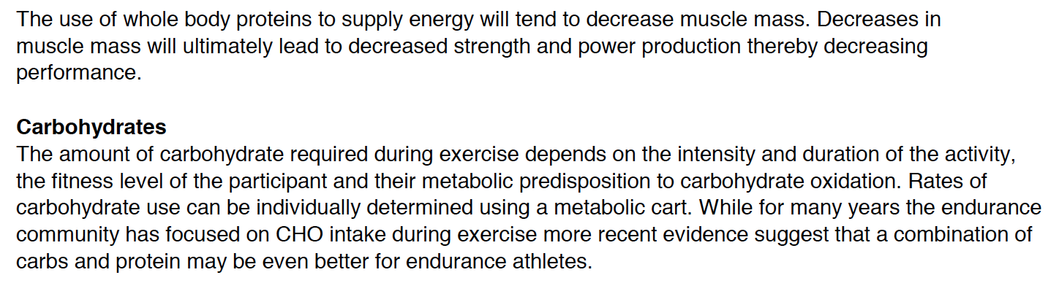

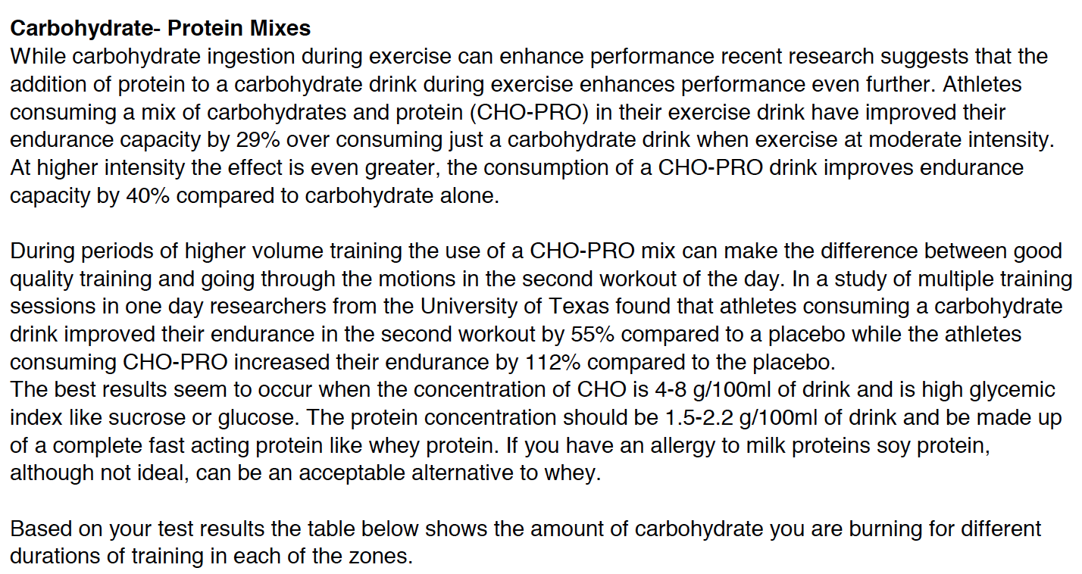

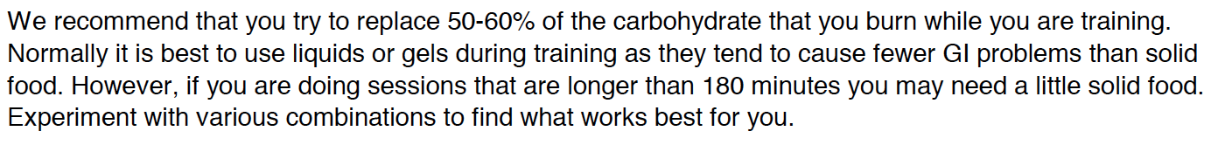

*Carbohydrate burning*

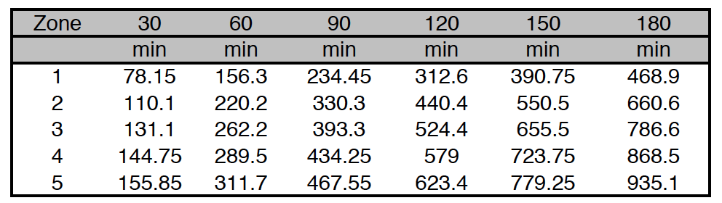



1. As an administrator/athlete, I can print the test result by pressing the printer icon.

**3. Training Plan**

**For administrators**

1. As an administrator, I can set training plan for athletes. I should input:

*Strength and Conditioning Schedule (Yellow fields need to be filled):*

|  |  |
| --- | --- |
| Period from | Period to |

|  |  |  |  |  |  |  |
| --- | --- | --- | --- | --- | --- | --- |
| Sunday | Monday | Tuesday | **Wednesday** | **Thursday** | **Friday** | **Saturday** |
| **Weekly Layout** | | | | | | |
| SW1  B3 &  B4 | OFF | ST1  B1  R2 | SW2  R1 | R3 | ST2 | SW3  B2 |
| **7** | **8** | **9** | **10** | **11** | **12** | **13** |
| SW 30’ B Z1 130’ ~200w | OFF | ST1  B Z1 35’  ~200w  R Z1 20’  5:13min/km | SW 30’  R Z3 15’  4:17/ 4:00min/km  R Z1 25’  5:13min/km | R Z1 50’  5:13min/km | ST2 | SW 30’  B Z3 15’  260/ 270w  B Z1 35’  ~200w |
| **14** | **15** | **16** | 17 | **18** | 19 | 20 |
| SW 30’ B Z1 135’ ~200w | OFF | ST1  B Z1 40’  ~200w  R Z1 20’  5:13min/km | SW 30’  R Z3 15’  4:17/ 4:00min/km  R Z1 25’  5:13min/km | R Z1 55’  5:13min/km | ST2 | SW 30’  B Z3 15’  260/ 270w  B Z1 35’  ~200w |
| **21** | **22** | **23** | 24 | **25** | 26 | 27 |
| SW 20’ B Z1 70’ ~200w | OFF | ST1  B Z1 25’  ~200w  R Z1 20’  5:13min/km | SW 20’  R Z3 5’  4:17/ 4:00min/km  R Z1 15’  5:13min/km | R Z1 55’  5:13min/km | ST2 | SW 20’  B Z3 5’  260/ 270w  B Z1 20’  ~200w |
| **28** | **29** | **30** | **Oct 1** | **2** | **3** | **4** |
| SW 30’ B Z1 145’ ~200w | OFF | ST1  B Z1 40’  ~200w  R Z1 25’  5:13min/km | SW 30’  R Z3 15’  4:17/ 4:00min/km  RZ1 30’  5:13min/km | R Z1 55’  5:13min/km | ST2 | SW 30’  B Z3 15’  260/ 270w  B Z1 40’  ~200w |

|  |  |  |  |  |  |
| --- | --- | --- | --- | --- | --- |
| **ST1** | | | | | |
| **Exercise** | | **Sets** | **Reps** | **Tempo** | **Rest** |
| A1. | Close Stance Back Squats | 3 | 6-8 | 3210 | 10s |
| A2. | Standing DB Overhead Press | 3 | 6-8 | 3210 | 120s |
| B1. | Romanian Deadlift | 3 | 8-10 | 3210 | 10s |
| B2. | DB Fat Gripz Bent Lateral Raise | 3 | 8-10 | 3210 | 90s |
| C1. | DB Step-Ups | 3 | 10-12 | 3210 | 10s |
| C2. | Pulley Face Pulls w/ External Rotation | 3 | 10-12 | 3210 | 60s |
| D. | Resistance Band Pull Aparts | 4 | 25 | N/A | 60s |

|  |  |  |  |  |  |
| --- | --- | --- | --- | --- | --- |
| **ST2** | | | | | |
| **Exercise** | | **Sets** | **Reps** | **Tempo** | **Rest** |
| A1. | Deadlift | 3 | 6-8 | 3210 | 10s |
| A2. | DB Chest Press | 3 | 6-8 | 3210 | 120s |
| B1. | DB Walking Lunge | 3 | 8-10 | 3210 | 10s |
| B2. | Pull Ups | 3 | 8-10 | 3210 | 90s |
| C1. | Leg Curls | 3 | 10-12 | 3210 | 10s |
| C2. | BB Bent Row | 3 | 10-12 | 3210 | 60s |
| D. | Resistance Band Pull Aparts | 4 | 25 | N/A | 60s |

*Flexibility Training (Yellow fields need to be filled):*

|  |  |  |
| --- | --- | --- |
| **Stretching Exercise** | **Sets** | **Hold (in sec)** |
| Lying quad stretch | 3 | 30 |
| Standing hamstring stretch | 3 | 30 |
| Groin stretch | 3 | 30 |
| Hip Flexor stretch | 3 | 30 |
| Glute stretch | 3 | 30 |
| Triceps Stretch | 3 | 30 |
| Cross shoulder stretch | 3 | 30 |
| Kneeling wrist stretch | 3 | 30 |
| Kneeling bench stretch | 3 | 30 |

1. As an administrator, I can view the training plan for every athlete. First I should choose the athlete name, period, then I can see:

As an athlete, I can view my own training plan. First I should choose period, then I can see:

*General Guidelines for Strength and Flexibility*

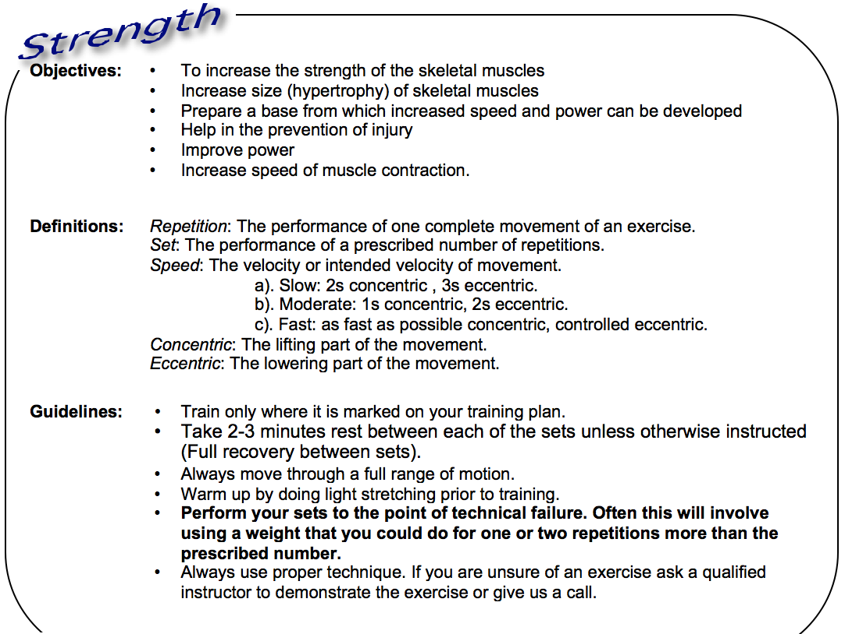

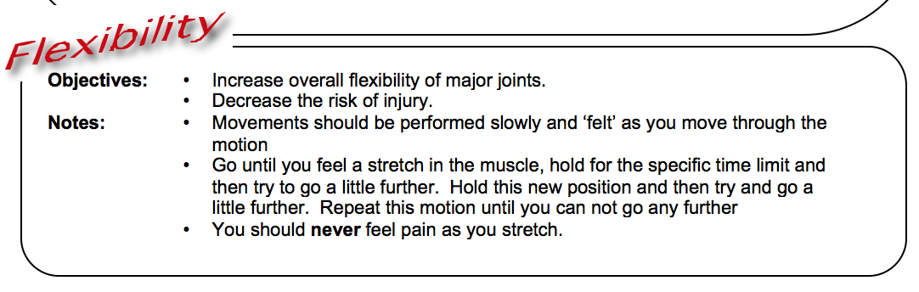

*AEROBIC Training Zones*

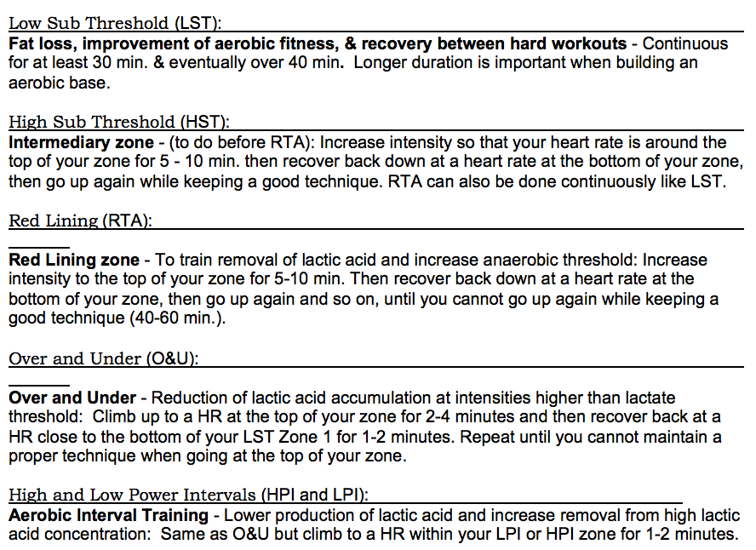

*Strength and Conditioning Schedule*

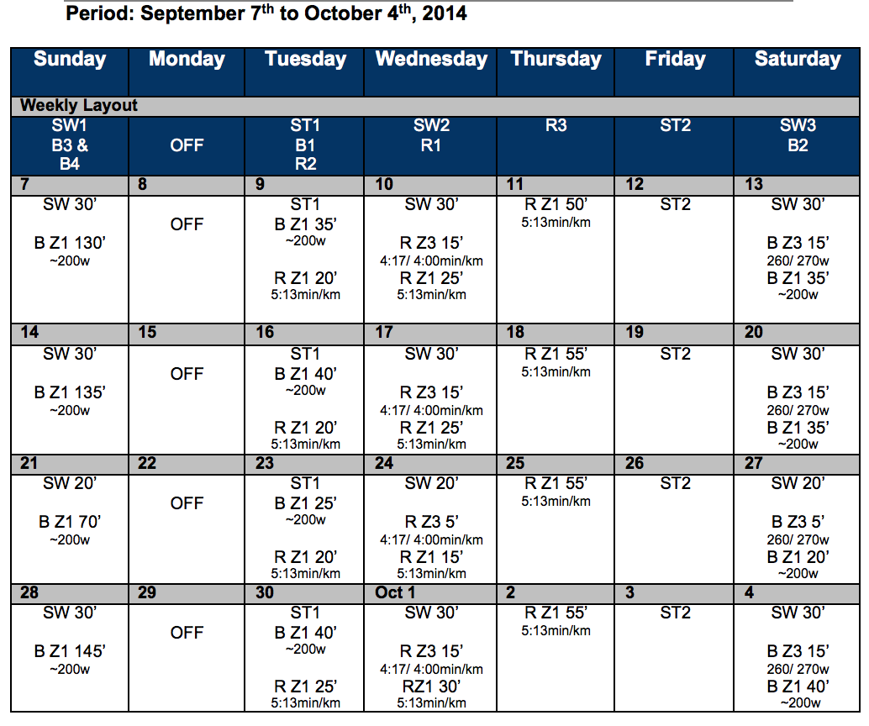

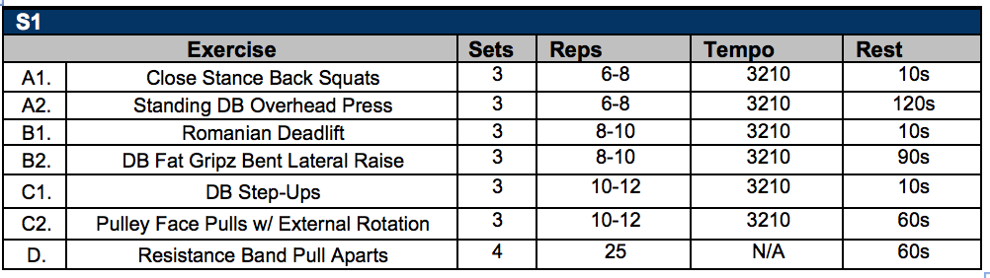

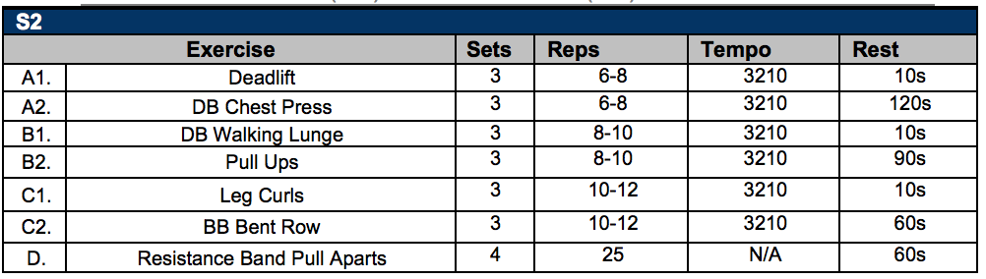

*Flexibility Training*

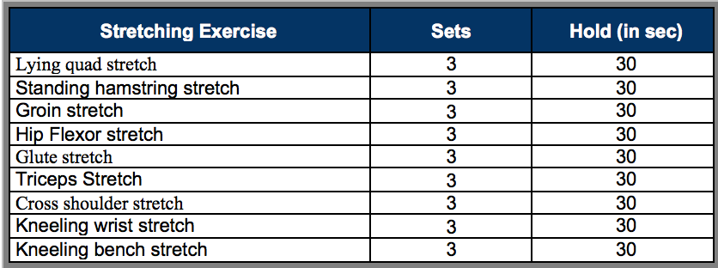

*Flexibility Training Images*

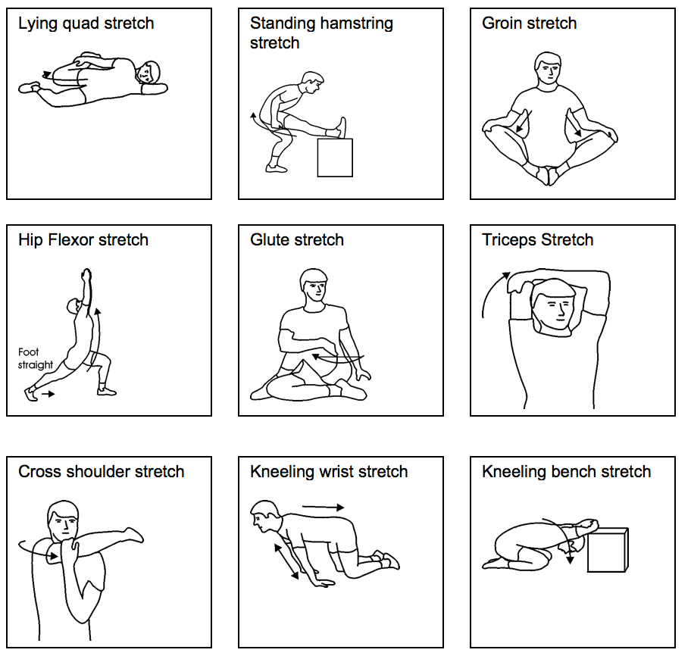

1. As an administrator, I can print anyone’s training plan by pressing the printer icon.

**4. Workout Summary**

**For athletes**

1. As an athlete, I can input my completion status of training plan. I should choose “Yes” or “No” to indicate whether I have completed the plan coach set.

*Strength and Conditioning Schedule:*

Top of Form

Bottom of Form

Top of Form

|  |  |  |  |  |  |  |
| --- | --- | --- | --- | --- | --- | --- |
| Sunday | Monday | Tuesday | **Wednesday** | **Thursday** | **Friday** | **Saturday** |
| **Weekly Layout** | | | | | | |
| SW1  B3 &  B4 | OFF | ST1  B1  R2 | SW2  R1 | R3 | ST2 | SW3  B2 |
| **7** | **8** | **9** | **10** | **11** | **12** | **13** |
| ○ Yes   No | ○ Yes   No | ○ Yes   No | ○ Yes   No | ○ Yes   No | ○ Yes   No | ○ Yes   No |
| **14** | **15** | **16** | 17 | **18** | 19 | 20 |
| ○ Yes   No | ○ Yes   No | ○ Yes   No | ○ Yes   No | ○ Yes   No | ○ Yes   No | ○ Yes   No |
| **21** | **22** | **23** | 24 | **25** | 26 | 27 |
| ○ Yes   No | ○ Yes   No | ○ Yes   No | ○ Yes   No | ○ Yes   No | ○ Yes   No | ○ Yes   No |
| **28** | **29** | **30** | **Oct 1** | **2** | **3** | **4** |
| ○ Yes   No | ○ Yes   No | ○ Yes   No | ○ Yes   No | ○ Yes   No | ○ Yes   No | ○ Yes   No |

whatBottom of Form

|  |  |  |  |  |  |  |  |  |  |  |  |  |  |  |  |  |  |  |  |  |  |  |  |  |
| --- | --- | --- | --- | --- | --- | --- | --- | --- | --- | --- | --- | --- | --- | --- | --- | --- | --- | --- | --- | --- | --- | --- | --- | --- |
| **ST1** | | | | | | | | | | | | | | | | | | | | | | | | |
| **Exercise** | **Week 1** | | | | | | **Week 2** | | | | | | **Week 3** | | | | | | **Week 4** | | | | | |
| Close Stance Back Squats | W |  |  |  |  |  | W |  |  |  |  |  | W |  |  |  |  |  | W |  |  |  |  |  |
| R |  |  |  |  |  | R |  |  |  |  |  | R |  |  |  |  |  | R |  |  |  |  |  |
| Standing DB Overhead Press | W |  |  |  |  |  | W |  |  |  |  |  | W |  |  |  |  |  | W |  |  |  |  |  |
| R |  |  |  |  |  | R |  |  |  |  |  | R |  |  |  |  |  | R |  |  |  |  |  |
| Romanian Deadlift | W |  |  |  |  |  | W |  |  |  |  |  | W |  |  |  |  |  | W |  |  |  |  |  |
| R |  |  |  |  |  | R |  |  |  |  |  | R |  |  |  |  |  | R |  |  |  |  |  |
| DB Fat Gripz Bent Lateral Raise | W |  |  |  |  |  | W |  |  |  |  |  | W |  |  |  |  |  | W |  |  |  |  |  |
| R |  |  |  |  |  | R |  |  |  |  |  | R |  |  |  |  |  | R |  |  |  |  |  |
| DB Step-Ups | W |  |  |  |  |  | W |  |  |  |  |  | W |  |  |  |  |  | W |  |  |  |  |  |
| R |  |  |  |  |  | R |  |  |  |  |  | R |  |  |  |  |  | R |  |  |  |  |  |
| Pulley Face Pulls w/ External Rotation | W |  |  |  |  |  | W |  |  |  |  |  | W |  |  |  |  |  | W |  |  |  |  |  |
| R |  |  |  |  |  | R |  |  |  |  |  | R |  |  |  |  |  | R |  |  |  |  |  |

|  |  |  |  |  |  |  |  |  |  |  |  |  |  |  |  |  |  |  |  |  |  |  |  |  |
| --- | --- | --- | --- | --- | --- | --- | --- | --- | --- | --- | --- | --- | --- | --- | --- | --- | --- | --- | --- | --- | --- | --- | --- | --- |
| **ST2** | | | | | | | | | | | | | | | | | | | | | | | | |
| **Exercise** | **Week 1** | | | | | | **Week 2** | | | | | | **Week 3** | | | | | | **Week 4** | | | | | |
| Deadlift | W |  |  |  |  |  | W |  |  |  |  |  | W |  |  |  |  |  | W |  |  |  |  |  |
| R |  |  |  |  |  | R |  |  |  |  |  | R |  |  |  |  |  | R |  |  |  |  |  |
| DB Chest Press | W |  |  |  |  |  | W |  |  |  |  |  | W |  |  |  |  |  | W |  |  |  |  |  |
| R |  |  |  |  |  | R |  |  |  |  |  | R |  |  |  |  |  | R |  |  |  |  |  |
| DB Walking Lunge | W |  |  |  |  |  | W |  |  |  |  |  | W |  |  |  |  |  | W |  |  |  |  |  |
| R |  |  |  |  |  | R |  |  |  |  |  | R |  |  |  |  |  | R |  |  |  |  |  |
| Pull Ups | W |  |  |  |  |  | W |  |  |  |  |  | W |  |  |  |  |  | W |  |  |  |  |  |
| R |  |  |  |  |  | R |  |  |  |  |  | R |  |  |  |  |  | R |  |  |  |  |  |
| Leg Curls | W |  |  |  |  |  | W |  |  |  |  |  | W |  |  |  |  |  | W |  |  |  |  |  |
| R |  |  |  |  |  | R |  |  |  |  |  | R |  |  |  |  |  | R |  |  |  |  |  |
| BB Bent Row | W |  |  |  |  |  | W |  |  |  |  |  | W |  |  |  |  |  | W |  |  |  |  |  |
| R |  |  |  |  |  | R |  |  |  |  |  | R |  |  |  |  |  | R |  |  |  |  |  |

1. As an athlete, I can print my own workout summary by pressing the printer icon.

For administrators

As an administrator, I can check all the athletes’ workout summary so that I can know well about the athletes’ training completion. I can see:

|  |  |  |  |  |  |  |
| --- | --- | --- | --- | --- | --- | --- |
| Sunday | Monday | Tuesday | **Wednesday** | **Thursday** | **Friday** | **Saturday** |
| **Weekly Layout** | | | | | | |
| SW1  B3 &  B4 | OFF | ST1  B1  R2 | SW2  R1 | R3 | ST2 | SW3  B2 |
| **7** | **8** | **9** | **10** | **11** | **12** | **13** |
| Yes  No | Yes  No | Yes  No | Yes  No | Yes  No | Yes No | Yes  No |
| **14** | **15** | **16** | 17 | **18** | 19 | 20 |
| Yes  No | Yes  No | Yes  No | Yes  No | Yes  No | Yes  No | Yes  No |
| **21** | **22** | **23** | 24 | **25** | 26 | 27 |
| Yes  No | Yes  No | Yes  No | Yes  No | Yes  No | Yes  No | Yes  No |
| **28** | **29** | **30** | **Oct 1** | **2** | **3** | **4** |
| Yes  No | Yes  No | Yes  No | Yes  No | Yes  No | Yes  No | Yes  No |

|  |  |  |  |  |  |  |  |  |  |  |  |  |  |  |  |  |  |  |  |  |  |  |  |  |
| --- | --- | --- | --- | --- | --- | --- | --- | --- | --- | --- | --- | --- | --- | --- | --- | --- | --- | --- | --- | --- | --- | --- | --- | --- |
| **S1** | | | | | | | | | | | | | | | | | | | | | | | | |
| **Exercise** | **Week 1** | | | | | | **Week 2** | | | | | | **Week 3** | | | | | | **Week 4** | | | | | |
| Close Stance Back Squats | W |  |  |  |  |  | W |  |  |  |  |  | W |  |  |  |  |  | W |  |  |  |  |  |
| R |  |  |  |  |  | R |  |  |  |  |  | R |  |  |  |  |  | R |  |  |  |  |  |
| Standing DB Overhead Press | W |  |  |  |  |  | W |  |  |  |  |  | W |  |  |  |  |  | W |  |  |  |  |  |
| R |  |  |  |  |  | R |  |  |  |  |  | R |  |  |  |  |  | R |  |  |  |  |  |
| Romanian Deadlift | W |  |  |  |  |  | W |  |  |  |  |  | W |  |  |  |  |  | W |  |  |  |  |  |
| R |  |  |  |  |  | R |  |  |  |  |  | R |  |  |  |  |  | R |  |  |  |  |  |
| DB Fat Gripz Bent Lateral Raise | W |  |  |  |  |  | W |  |  |  |  |  | W |  |  |  |  |  | W |  |  |  |  |  |
| R |  |  |  |  |  | R |  |  |  |  |  | R |  |  |  |  |  | R |  |  |  |  |  |
| DB Step-Ups | W |  |  |  |  |  | W |  |  |  |  |  | W |  |  |  |  |  | W |  |  |  |  |  |
| R |  |  |  |  |  | R |  |  |  |  |  | R |  |  |  |  |  | R |  |  |  |  |  |
| Pulley Face Pulls w/ External Rotation | W |  |  |  |  |  | W |  |  |  |  |  | W |  |  |  |  |  | W |  |  |  |  |  |
| R |  |  |  |  |  | R |  |  |  |  |  | R |  |  |  |  |  | R |  |  |  |  |  |

|  |  |  |  |  |  |  |  |  |  |  |  |  |  |  |  |  |  |  |  |  |  |  |  |  |
| --- | --- | --- | --- | --- | --- | --- | --- | --- | --- | --- | --- | --- | --- | --- | --- | --- | --- | --- | --- | --- | --- | --- | --- | --- |
| **S2** | | | | | | | | | | | | | | | | | | | | | | | | |
| **Exercise** | **Week 1** | | | | | | **Week 2** | | | | | | **Week 3** | | | | | | **Week 4** | | | | | |
| Deadlift | W |  |  |  |  |  | W |  |  |  |  |  | W |  |  |  |  |  | W |  |  |  |  |  |
| R |  |  |  |  |  | R |  |  |  |  |  | R |  |  |  |  |  | R |  |  |  |  |  |
| DB Chest Press | W |  |  |  |  |  | W |  |  |  |  |  | W |  |  |  |  |  | W |  |  |  |  |  |
| R |  |  |  |  |  | R |  |  |  |  |  | R |  |  |  |  |  | R |  |  |  |  |  |
| DB Walking Lunge | W |  |  |  |  |  | W |  |  |  |  |  | W |  |  |  |  |  | W |  |  |  |  |  |
| R |  |  |  |  |  | R |  |  |  |  |  | R |  |  |  |  |  | R |  |  |  |  |  |
| Pull Ups | W |  |  |  |  |  | W |  |  |  |  |  | W |  |  |  |  |  | W |  |  |  |  |  |
| R |  |  |  |  |  | R |  |  |  |  |  | R |  |  |  |  |  | R |  |  |  |  |  |
| Leg Curls | W |  |  |  |  |  | W |  |  |  |  |  | W |  |  |  |  |  | W |  |  |  |  |  |
| R |  |  |  |  |  | R |  |  |  |  |  | R |  |  |  |  |  | R |  |  |  |  |  |
| BB Bent Row | W |  |  |  |  |  | W |  |  |  |  |  | W |  |  |  |  |  | W |  |  |  |  |  |
| R |  |  |  |  |  | R |  |  |  |  |  | R |  |  |  |  |  | R |  |  |  |  |  |

1. As an administrator, I can print anyone’s workout summary by pressing the printer icon.